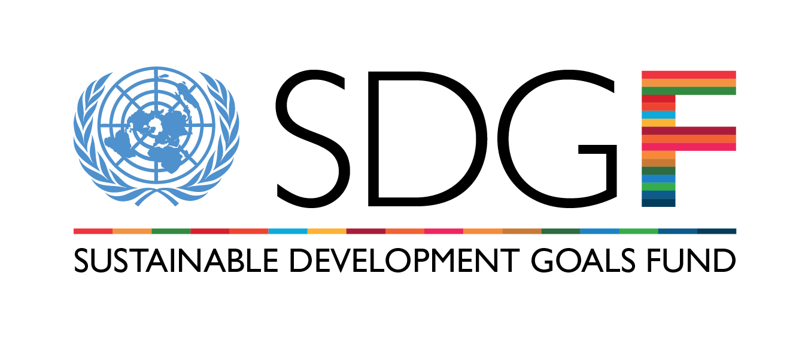

Call for Proposals
Concept Note Form

Please review the Terms of Reference and Guidance document carefully before completing the Concept Note Form
I. Programme contact information
Country
Resident Coordinator
Name
E-mail
UNCT Contact Person for application
Name
Agency
Title
E-mail
Telephone number (include country and city code)
Address
UNCT Contact Person for application
Name
Agency
Title
E-mail
Telephone number (include country and city code)
Address

II. Programme summary
Programme title.
Sectorial area of intervention and policy objectives: Please select the area to which you are applying |  Inclusive economic growth  - Create opportunities for decent jobs and secure livelihoods.  - Create better government policies and fair and accountable public institutions.  - Promote inclusive and sustainable business practices.   Food security and nutrition  - Integrated approaches for alleviating child hunger and undernutrition.  - Promote sustainable and resilient livelihoods for vulnerable households, especially in the context of adaptation to climate change.  - Strengthen capacities to generate information through assessment, monitoring and evaluation.   Water and sanitation  - Promote democratic and transparent water and sanitation governance systems.  - Improve access to water and sanitation services for the poor and marginalized.  - Ensure healthy lives through sanitation and hygiene education.  - Promote integrated water governance and climate change adaptation.
Joint programme summary. Brief description of what the joint programme aims to achieve and the means it will deploy to achieve the objectives (max.750 words)
Duration (starting and closing date. It can´t be more than 2 years. Each programme will count with inception phase of 4 months that is not included as part of these 2 years)
UN Lead Agency
UN Participating Organizations
Local Partners (list all national partners including national, regional and local authorities, civil society organizations, research institutions and private sector)

III. Programme budget
Total amount requested from the SDG-F (in US dollars)
Total contribution through matching funds (in US dollars)
Aggregate amount requested and broken down by Agency:
Agency 1 (Name of Agency / Amount in US dollars)
Agency 2 (Name of Agency / Amount in US dollars)
Agency 3 (Name of Agency / Amount in US dollars)
Agency 4 (Name of Agency / Amount in US dollars)
Agency 5 (Name of Agency / Amount in US dollars)
Aggregate matching funds amounts and broken down by source:
Short explanation of strategy and sources to mobilize matching funds
Source 1 (Name of source / Amount in US dollars)
Source 2 (Name of source / Amount in US dollars)
Source 3 (Name of source / Amount in US dollars)
Source 4 (Name of source / Amount in US dollars)
Source 5 (Name of source / Amount in US dollars)
Formulation Costs for the Joint Programme: Where a Concept Note has been approved by the Steering Committee, the UNCTs may apply for up to $10,000 as an advance on the full programme to support the formulation costs. If you wish to apply for this advance, please designate:
Amount (in US dollars)
A lead agency who will manage these funds. Please identify only one agency

IV. Programme description
Background and rationale. This section should include the following information:
- Problem(s) to be addressed, including its/their scope, history and causes
- Intended beneficiaries and geographic area of intervention (with baseline data)
- Priority the Government attaches to the problem(s) and the key public policies in place
- Relation of the proposed Joint Programme to existing national planning and policy instruments
- Summary of ongoing or recently completed efforts in the area and the principal local, national and international actors involved in the issue
- Relation to ongoing activities in the field; innovation and /or complementarity of the JP with on-going/planned interventions
- Contribution to achieving the MDG(s), other international commitments on the issue at national level
- Alignment to UNDAF principles
- Inclusion of a sustainability perspective (sustainability of results and environmental sustainability).
- Gender and women’s empowerment analysis.
- Potential public-private partnerships synergies.
**Optional: Please upload additional background information if necessary. NB: This space is for additional background information only, please do not upload the entire Concept Note Narrative; enter all the required information in the fields provided.
Mainstreaming of gender and women’s empowerment. This section should explain how the programme intends to include a gender perspective.
- Describe how gender and women’s empowerment have been considered in the JP design, implementation and management
- Highlight specific, measurable outcomes, outputs, activities and indicators related to gender equality and women’s empowerment
Sustainability. This section should explain how the programme intends to include an environmental perspective and ensure that results are sustained in the longer term.
- Describe how environment and climate change issues have been considered in the JP design, implementation and management
- Highlight specific, measurable outcomes, outputs, activities and indicators related environment and climate change
- Explain how the programme intends to sustain the results in the longer term after the joint programme’s termination.
Public-private partnerships. This section should describe how the programme intends to promote public-private partnerships.
Civil society participation. This section should describe the level of participation of civil society in decision making processes, design, implementation, monitoring and evaluation
Justification of the Joint Programme modality. This section should include the following information:
- Conditions that would make a Joint Programme the most effective approach (common priority area for implementing partners, multi-dimensional development problem, convergent priority geographical areas, scalability, etc.)
- Added value of the UN Agencies and national partners
- Previous experiences of the UN Agencies in JPs
Regions of intervention (Regions and criteria for selection)

Targeted groups. Primary beneficiaries: who will benefit from this project and whose lives are expected to change? Please, include gender sensitive indicators and information.
Design, mutisectorial strategy, results and implementation plan. This section should include the following information:
- Multisectoral approach
- JP Theory of Change
- Intended outcomes, outputs, activities and budget of the proposed JP (Result Framework Matrix)
- Regional overview of the intervention (results by region)
- Measurable outputs to be delivered, outcomes to which they will contribute and their relationship; budget by output
- Enhanced local/national capacities that will be present at the end of the Joint Programme
- Measures to ensure sustainability of results
** Required: Please upload your Results Framework at the moment of submitting the proposal.
Coordination and governance arrangements. This section should include the following information:
- General overview of National coordination system and regional/local coordination systems
- Approach to and overview of sectoral and regional coordination
- Identification of potential members of the Governance Structures
- Overview of the information system
Risk analysis. This section should describe the programme’s potential risks and mitigation strategy regarding:
- Achievement of Joint Programme results
- Effective interagency and inter-institutional coordination
- Multisectoral approach
Monitoring and evaluation (M&E). This section should explain how the programme intends monitor and evaluate its results. It should include the following information:
- Monitoring and Evaluation indicators matrix (qualitative/quantitative)
- Methodology for data collection and analysis
- Indicators baselines, if available, will be highly valued
- Measures to ensure joint implementation of M&E activities
- Estimated allocation of resources for M&E
- Link to Knowledge Management and Communication and Advocacy activities
Communication and advocacy (C&A). This section should explain how the programme intends to incorporate communication and advocacy actions. It should include the following information:
- Communication and advocacy overview (communication objectives, audiences and activities)
- Estimated allocation of resources for C&A
- Measures to ensure joint implementation of C&A activities
- Link to knowledge management and monitoring and evaluation activities
Knowledge management (KM). This section should explain how the programme intends to gather, generate and disseminate knowledge:
- KM overview (objectives, audience and activities)
- Link to monitoring and evaluation and communication and advocacy activities
Contribution to the post 2015 development Agenda. Please explain, how the JP is going to contribute to the national and global discussion on the post 2015 development agenda and to the transition from the MDGs to the SDGs.

V. Please add the following annexes before submission
- Letter signed by Resident Coordinator
- CN Endorsement of National Steering Committee
- Commitment of matching funds
- Results Framework (use of SMART output methodology up to the activity level, and including budget)
- Budget break-down per outcomes, outputs and activities (refer to results matrix)
- Budget break-down per UN Agency
- Minutes of formulation meetings and events
- Participants list of consultation meetings and events

